**DATA DOAMIN JOBS ANALYSIS PROBLEM**

**REPORT**

Question 1-> **The company is facing challenges in understanding hiring trends over the years, which impacts strategic workforce planning. Without a clear visual representation of job openings, it's difficult to identify peak hiring periods and adjust recruitment strategies accordingly. This lack of insight can lead to missed opportunities in talent acquisition and inefficient resource allocation. A comprehensive visual analysis is needed to inform decision-making and enhance the effectiveness of hiring initiatives.**

Solution-> To address the challenge of understanding hiring trends, we propose creating a detailed visual analysis using a bar chart that illustrates the number of job openings for each month across multiple years. This chart will:

* Provide a clear, year-wise and month-wise view of job openings.
* Help identify peak hiring periods and seasonal patterns in recruitment.
* Enable data-driven decision-making for workforce planning and resource allocation.
* Support the development of more targeted and timely recruitment strategies.

By visualizing historical hiring data in this format, the company can gain valuable insights into recruitment trends, improve strategic planning, and optimize talent acquisition efforts.

**🔍 Useful Insights from the Hiring Trends Bar Chart:**

1. **Identification of Peak Recruitment Periods:**  
   The visual clearly highlights months with the highest job openings across different years, allowing the company to **anticipate hiring surges** and prepare recruitment resources accordingly (e.g., during Q1 or post-fiscal year periods).
2. **Seasonal and Market Behavior Trends:**  
   By comparing year-over-year patterns, the company can detect **seasonal fluctuations or economic impacts** (e.g., hiring drops during pandemics or holidays), helping align workforce planning with broader market conditions and ensuring agility in recruitment strategies.

Dax query

Average opening =

var test_year=YEAR(SELECTEDVALUE(job_postings1csv[MONTH_YEAR]))

var test_month=MONTH(SELECTEDVALUE(job_postings1csv[MONTH_YEAR]))

var first_day=CALCULATE(MIN(job_postings1csv[JOB_POSTING_DATE]),YEAR(job_postings1csv[JOB_POSTING_DATE])==test_year && MONTH(job_postings1csv[JOB_POSTING_DATE])==test_month)

var last_day=CALCULATE(MAX(job_postings1csv[JOB_POSTING_DATE]),YEAR(job_postings1csv[JOB_POSTING_DATE])==test_year && MONTH(job_postings1csv[JOB_POSTING_DATE])==test_mo

var days_differnce=if(test_year=2022,DATEDIFF(first_day,last_day,DAY)+1,DATEDIFF(first_day,last_day,DAY))

var job openings=COUNT(job_postings1csv[JOB_ID])

return job_openings /days_differnce

visual

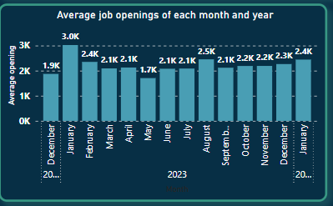

Problem 2->**The company is facing challenges in understanding the distribution of job types, such as work-from-home and remote positions, across different years. Analysing the number of companies offering each job type, along with their contribution to the total jobs for those years, is essential for recognizing evolving employment trends. This insight will enable more strategic recruitment planning and better alignment with market demands, ultimately enhancing the company’s hiring effectiveness.**

Solution-> To effectively analyze the distribution of job types (such as work-from-home and remote positions) across different years and understand evolving employment trends, we propose the following data-driven approach:

1. **Calculate the Total Number of Companies per Year:**  
   Begin by determining the total number of unique companies that posted jobs in each year.
2. **Determine the Number of Companies per Job Type per Year:**  
   For each job type (e.g., remote, work-from-home, on-site), calculate the number of unique companies offering those types of positions in each year.
3. **Calculate the Percentage Contribution:**  
   For each job type, divide the number of companies offering that job type by the total number of companies for that year. Multiply by 100 to convert this to a percentage:
4. **Create a Table Visual:**  
   Display the results in a table with the following columns:
   * **Year**
   * **Job Type**
   * **Number of Companies**
   * **Total Companies (Year)**
   * **Percentage Contribution**

**🔍 Insights from the Job Type Distribution Table:**

1. **How Work Styles Are Changing Over Time:**  
   The table shows if more companies are offering remote or work-from-home jobs each year. If those numbers are going up, it means **remote work is becoming more popular**, and the company should also offer flexible jobs to attract more candidates.
2. **Are We Keeping Up with Other Companies?**  
   By looking at how many companies offer each type of job, the company can see if it is **doing the same as others in the industry**. If most companies are offering remote jobs but this company isn’t, it might be **missing out on good talent**

Dax query

company = SUMX(VALUES(job_postings1csv[JOB_TYPE]),CALCULATE(DISTINCTCOUNT(job_postings1csv[COMPANY_NAME])))

PercentageOfRowTotal =

var rowtotal=CALCULATE([company],ALL(job_postings1csv[JOB_TYPE]))

RETURN [company]/rowtotal

Visual

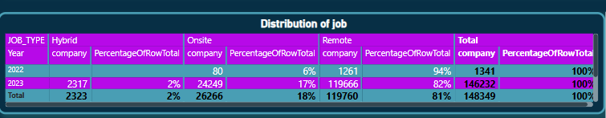

**Problem 3-> The company seeks to identify the top three job fields for each year to understand the most in-demand sectors within the job market. By analysing these trends annually, the organisation can better align its recruitment strategies with emerging industry needs and capitalise on growth opportunities. This insight will enhance the company’s ability to attract talent in high-demand areas, ensuring that it remains competitive and responsive to market dynamics.**

**Solution->**To identify the top 3 job types with the highest number of openings per year, a DAX measure was created using the TOPN function. It filters job postings by the selected year, excludes unspecified job fields, and counts job openings per job field. Then, it selects the top 3 job fields based on the number of postings and combines them into a comma-separated list using CONCATENATEX. This helps the company understand dominant job types over time, enabling better recruitment focus and alignment with market demand.

**🔍 Useful Insights from the Top 3 Job Fields Analysis:**

1. **Focus on High-Demand Job Areas:**  
   By identifying the top 3 job fields for each year, the company can clearly see **which sectors are growing the fastest**. This helps prioritize recruitment in those fields to attract top talent and meet market needs.
2. **Stay Ahead of Industry Trends:**  
   Tracking how the top job fields change each year allows the company to **spot new and emerging sectors early**. This means the organization can adjust its hiring plans in time and **stay competitive in a changing job market**.

Dax query

Top3JobsDomainPerYear =

var current_year=SELECTEDVALUE(job_postings1csv[JOB_POSTING_DATE].[Year])

var TopDomains= TOPN(3,

              SUMMARIZE(FILTER(job_postings1csv,YEAR(job_postings1csv[JOB_POSTING_DATE])=current_year

              && job_postings1csv[JOB_FIELD]<>"No Clear Specifications"),

              job_postings1csv[JOB_FIELD],"JobCount",COUNT(job_postings1csv[JOB_ID])),[JobCount],DESC)

RETURN

      CONCATENATEX(TopDomains,job_postings1csv[JOB_FIELD],",")

Visual

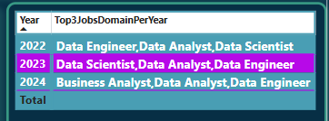

**Problem 4-> The company aims to determine the average number of companies hiring over time to gauge overall market activity and stability. By analysing hiring trends, the organisation can identify fluctuations in recruitment practices and understand the competitive landscape better. This insight is essential for strategic workforce planning and can guide efforts in talent acquisition, ensuring that the company remains agile in adapting to changing market conditions.**

**Solution->** To determine the average number of companies hiring over time, a DAX measure was created that calculates the daily average of unique hiring companies for each month and year.

Here's how the DAX works:

* It identifies the selected month and year from the data.
* It finds the first and last job posting dates for that month to calculate the total number of active days.
* It counts the number of distinct companies that posted jobs during that period.
* Finally, it divides the total companies by the number of days to get the average number of companies hiring per day for that month.

This insight is visualized using a bar chart across months and years. It helps the company:

* Track hiring activity trends over time.
* Spot periods of high or low recruitment activity.
* Understand market stability and competition for talent.

This analysis supports strategic workforce planning by revealing when the market is most active, enabling the company to time its recruitment efforts more effectively.

**🔍 Useful Insights from the Average Hiring Companies Analysis:**

1. **Know When Hiring is Most Active:**  
   By seeing which months have the highest average number of companies hiring, the company can **plan its recruitment during busy periods** to stay competitive and attract more candidates.
2. **Understand Market Stability:**  
   If the number of hiring companies stays steady over time, it shows a **stable job market**. But if it changes a lot, it signals shifts in the market—helping the company stay prepared and **adjust its hiring strategies quickly**.

Dax query

Average Company =

var test_year=YEAR(SELECTEDVALUE(job_postings1csv[MONTH_YEAR]))

var test_month=MONTH(SELECTEDVALUE(job_postings1csv[MONTH_YEAR]))

var first_day=CALCULATE(MIN(job_postings1csv[JOB_POSTING_DATE]),YEAR(job_postings1csv[JOB_POSTING_DATE])==test_year && MONTH(job_postings1csv[JOB_POSTING_DATE])==test_month)

var last_day=CALCULATE(MAX(job_postings1csv[JOB_POSTING_DATE]),YEAR(job_postings1csv[JOB_POSTING_DATE])==test_yeear && MONTH(job_postings1csv[JOB_POSTING_DATE])==test_month)

var days_differnce=if(test_year=2022,DATEDIFF(first_day,last_day,DAY)+1,DATEDIFF(first_day,last_day,DAY))

var job_openings=DISTINCTCOUNT(job_postings1csv[COMPANY_NAME])

return job_openings/days_differnce

Visual

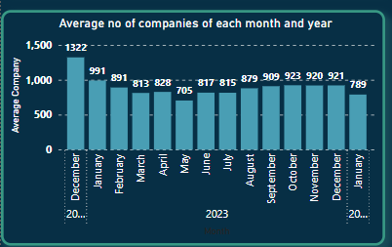

**Problem 5->** **The company needs to identify which job types have the highest number of openings for each country and year. Understanding the dominant job types in various regions over time is crucial for tailoring recruitment strategies and addressing local market demands. This analysis will provide valuable insights into global hiring trends, allowing the company to focus its efforts on the most sought-after positions in specific countries and improve its overall talent acquisition approach.**

**Solution->** To identify the most in-demand job type for each country and year, a DAX measure named MaxJobFieldsPerCountryYear is used. This measure:

* Captures the selected country and year from the visual context.
* Filters the job data to include only valid job fields for that specific country and year.
* Groups the data by job field and counts the number of job postings for each.
* Determines which job field has the highest number of postings in that region and year.
* Returns the job field with the maximum postings, i.e., the most dominant job type.

🔍 **Insights from the DAX Analysis:**

1. **Localized Demand Awareness:**  
   The measure reveals which job type is most in demand in each country and year, helping the company tailor job offerings based on regional trends.
2. **Strategic Hiring Focus:**  
   By identifying the top job field per country, recruitment teams can focus efforts on roles that align with the market demand, improving success rates.
3. **Global Trend Recognition:**  
   Aggregating this data across multiple regions over time allows the company to detect shifts in global job demand, helping anticipate future needs.
4. **Improved Talent Acquisition:**  
   This insight ensures the company targets high-demand roles in relevant regions, optimizing resource allocation and reducing time-to-hire.

Dax query

MaxJobFieldsPerCountryYear =

var current_country=SELECTEDVALUE(job_postings1csv[JOB_LOCATION_COUNTRY])

var current_year=YEAR(SELECTEDVALUE(job_postings1csv[JOB_POSTING_DATE]))

var MaxFieldTable=

                SUMMARIZE(FILTER(job_postings1csv,job_postings1csv[JOB_LOCATION_COUNTRY] =current_country

                && job_postings1csv[JOB_POSTING_DATE].[Year]=current_year &&

                job_postings1csv[JOB_FIELD]<>"No clear Specifications"),

                job_postings1csv[JOB_FIELD],"PostingCount",COUNT(job_postings1csv[JOB_ID]))

var MaxPosting=MAXX(MaxFieldTable,[PostingCount])

RETURN

MAXX(FILTER(MaxFieldTable,[PostingCount]=MaxPosting),job_postings1csv[JOB_FIELD])

Visual

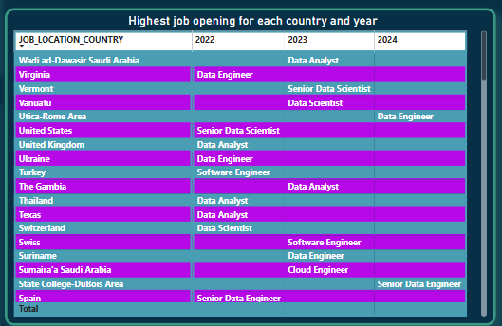

**Problem 6->** **The company is looking to visualise the most in-demand skills to better understand workforce requirements and guide training and development initiatives. By creating a clear visual representation of these skills, stakeholders can identify key areas where talent is lacking and prioritise skill development efforts accordingly. This analysis will help align the organisation’s workforce capabilities with market demands, ensuring that employees possess the skills necessary to thrive in their roles and contribute effectively to the company’s success**.

**Solution->** To identify the most in-demand skills, we use a **Word Cloud visual** in Power BI. This visualization displays skill keywords based on their **frequency of occurrence** in the job postings. The larger the word appears, the more frequently that skill is mentioned, indicating higher demand in the job market.

This visual approach helps stakeholders quickly recognize the **most commonly required skills**, enabling better alignment of workforce capabilities with market expectations.

**🔍 Useful Insights:**

1. **Targeted Skill Development:**  
   The word cloud highlights high-demand skills, helping HR and learning teams prioritize training programs and upskilling initiatives in areas where talent gaps exist.
2. **Workforce-Market Alignment:**  
   By visualizing trending skills, the company can ensure that employee competencies are aligned with industry needs, improving productivity and increasing competitiveness in the market.

Visual

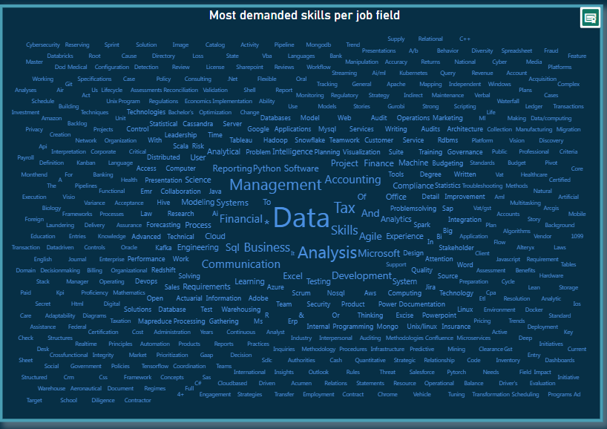

**link of the dashboard-**<https://app.powerbi.com/view?r=eyJrIjoiYjAwMWUwZmQtOGEwOC00MDFmLWFhM2EtYTc2NDM5MTc5YTgzIiwidCI6ImI1M2FmNGY3LTE2ZTUtNGJjOC1iNjM5LWZjNTE0YTA0ZDllYiJ9>